**Lab 5 “Thrust” SFML**

**Deadline 28th Feb 2018**

**Create a physics based Spaceship**

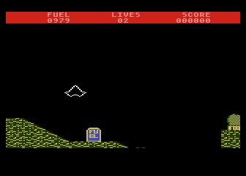

Thrust Atari ST

<https://youtu.be/xwv3jIzVY4Y?t=36s>

1. **Engine:**

When the spaceship is in the air and **‘w’ is hit** by the user apply a thrustForce in the direction that the spaceship is pointing to the velovity. As you hold ‘w’ it will keep applying a thrustForce until maximum speed has been reached.

You rotate the spaceship by pressing ‘d’ for clockwise rotation and ‘a’ for anti-clockwise rotation. This rotation changes its **Velocity** vector.

If the spaceship hits the “ground” a life is lost.

In this simulation each pixel is a meter. To enable to simulation to be more useful for games etc.

use a scaling variable called **const** **float pixelToMeter**

**gravity(0**, **9.81**\* **pixelToMeter);**

Experiment with different values of pixeltoMeter to get a ‘nice’ engine thrust effect.

**(50 marks)**

**2 Shooting:**

When **the a-key** is pressed the rocket shoots missiles ( make them circles or circular images) in the direction its facing. The spaceship can shoot multiple missiles

**(30 marks)**

**3. Easy target**

Create a target on screen that the player can shoot. If the missile hits the target the target respawns randomly on the screen and the players score increases. If the player collides with the target the player loses a life.

**(20 Marks)**